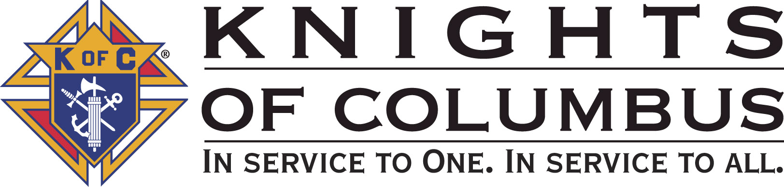

Council #13672 at Divine Savior Fr. Neil W. Seidl
Orangevale, CA
January 2010 Volume 7, #1

Monthly Grand Knight’s Message
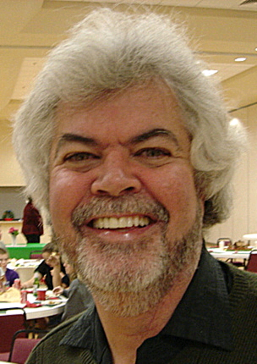
Grand Knight Charlie McDermott

Dep. Grand Knight Bruce Pyle

Fin. Secretary Micheal Wagner

Treasurer Allen Brown

Chancellor Tom Hogan

Warden Bob Reilly

Advocate Dave Brodie

Recorder Ray Coughlin

Trustee 1st Year Bill Windle (PGK)

Trustee 2nd Year Mike Duskus (PGK)

Trustee 3rd Year Joe Luchi (PGK)

Inside Guard Steve Mann

Outside Guard Douglas Copley

Chaplin Fr. Roman Mueller

Lecturer Tom Lawson

Field Agent Tony Magdaleno

The Knights of Columbus Council #13672 at Divine Savior Fr. Neil W. Seidl Chapter meets Monthly on the First Tuesday of each month at 7:00 p.m.
Please join us to help our Catholic Community.
For insurance needs, please contact our Field Agent Tony Magdaleno at 470-9205 or by mail at
P.O. Box 2737
Rancho Cordova, CA 95741

Greetings Brother Knights:

Happy New Year to each of you! I hope you were all able to enjoy Christmas and celebrate the birth of our Lord, Jesus Christ. January marks the beginning of the second half of the 2009/10 Columbian Year. It also marks the beginning of the end for my time as acting Grand Knight. I have to say that time does march quickly, but I can also say that we have made the best of our time together. I appreciate all the hard work of our Council’s Officers, Trustees, Service Program Directors and fellow Knights. Thank you all for making the first half of our Columbian Year a very successful one.


So what is in store for the second half of the Columbian Year? We have a number of events planned including the upcoming Free Throw Competition, Pancake/Blood Drive and Spaghetti Dinner Fundraiser for the Parish Building Fund in January alone. And more events and fundraisers already are in place throughout the rest of the year. Our last official Membership Drive comes in February and as I talked about last Business Meeting- this is an area that I need each of you to help with. We need 12 new knights and we currently sit at 3 new Knights with 3 additional awaiting 1st Degree completion. Please make a point of asking a church member to consider joining. In terms of improvement, the area that needs work is getting the community more involved with us and us with the community. Tony Aeillo has graciously agreed to head up a committee to look at ways to improve that relationship through a marketing effort.

Finally, planning for next Columbian Year begins. The old sayings “that you can never plan early enough” and “the early bird gets the worm” are so appropriate for essential planning for the next Columbian Year. To that end, my Deputy Grand Knight and Program Director Bruce Pyle and our Service Program Directors are already discussing activities and events possibilities for the next Columbian Year. So if you have input or want to get involved with next year’s planning, please contact your Service Program Director or Bruce Pyke with your thoughts.

This is such a wonderful Council and we are blessed to have so many active participants in all we do So let us continue our journey in being of service to our parish, community and to each other and don’t forget to laugh and have fun along the way!

God Bless us all.

Charlie McDermott,
Grand Knight
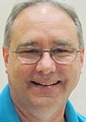
Treasurer Report
(As presented by Allen Brown)

Account balances as of 1-1-2010

Business Account Statement Balance $5,598.18
Not cleared # 1730 Dan Freeman - $110.70
Not cleared # 1758 Charles McDermott - $186.53
------------------------------------------------------
Business Account Actual Balance $5,300.95

Charity Account Statement Balance $240.12
Not cleared #1068 Nor Cal Special Oly - $100.00
------------------------------------------------------
Charity Account Actual Balance $140.12

CD 50 balance $1080.65
CD 51 balance $1071.43
CD 52 balance $1071.40

Total actual balance is $8,664.55 versus bank statement of $9,061,78

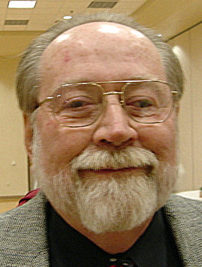

Financial Secretary’s Corner
(As presented by Michael Wagner)

Review of the 2009/2010 Budget after 4 Months

At the request on the Grand Knight, I have reviewed the “approved” budget figures against the “actual” budget figures. The approved budget had expected receipt of $35,500 and expenses of $37,400, leaving a $1,900 shortage.

After 4 months (thru November business meeting), we have receipts of $12,300 and expenses of $12,500, a shortage of $200. This is after 3 of or 5-scheduled major fundraisers and 2 of 6 pancake breakfasts. Expected proceeds for Hoedown and Oktoberfest were $2,400 short of projections. Remaining fundraisers are scheduled to generate $6,600.

Expenses are in line with projection, with the exception of the Parish Hall Usage, where we overstated it by $800.

Charities account for $12,500 of our expenses, 14 minor gifts of $1,900 and 4 major gifts of $10,600. We have received donations of $700 towards our charity gifts and donated $2,300 so far; notability, $700 to the Wheelchair Foundation and $1,100 to the parish retaining wall project. The remaining minor gifts will be made in the next 4 to 5 months. The remaining major gifts, Parish Building Fund, Scholarships, and Wheelchair Foundation, account for $7,000. The Parish Building Fund and American Wheelchair Mission donations were based on our ability to raise sufficient funds and might need to be scaled back The Grand Knight is planning a donation request next month to offset part of the Wheelchair Foundation gift. The ID Drive proceeds are not included in the above figures, as it is a pass thru charity.

In summary, we are NOT in financial troubles as we have sufficient funds in the bank accounts to cover all expenses and gifts. Dues collection will start in January, raising $3,100. But, we do need to look at ways to increase proceeds from our fundraisers and keep a handle on expenses.

December Receipts

Batch 21 $507.00
Christmas Social $457.00
Raffle $50.00
Batch 22 $718.34
Recycle Day 2 $380.10
Christmas Social $260.72
Pancake Breakfast $77.52
Batch 23 $163.00
Recycle Day 2 $163.00
Grand Total $1388.34

2010 Dues
There will be a vote on the motion the raise council dues to $37.00 at the January business meeting. Dues billings will be mailed right after the decision on the increase.

Annual Fraternal Survey

IRS requires all fraternal organizations, such as the Knights of Columbus, to fill annual statements of volunteerism. To gather this information, each Knight is asked to complete the “Annual Survey of Fraternal Activity – Individual Member Worksheet” and submit it to the Financial Secretary. Each Council is required to tabulate these figures and report them to Supreme by January 31, 2010. I am asking you to aid in this task by completing your form and returning it to me as soon as possible. If you have any questions, please call me at 966-6733. The form is attached to the newsletter,


Knight of the Month
(As presented by Charlie McDermott)

Knight of the Month for January is Kelvin Joiner

This brother Knight took on the responsibility of being one of our Council’s Service Program Directors. What’s interesting is that he took on that assignment with less than 9 months experience within the Knights of Columbus. He also took on the assignment knowing that in all probability he would not be here for the entire Columbian Year. But he thought he could help and he thought he could make a difference. For you see, what he brought to our Council was a willingness to get involved, willingness to learn, willingness to organize his team and make things happen. His work on the Recycle/Technology Drive was very successful from a fundraising standpoint very well done and he has done a wonderful job of keeping our Council up to date on events coming up within his Committee. As many of you may know, his father is needing more personal care and help around the house, so they are planning to move from the area in the next month or two. We are sorry to see Kelvin and his family move, but we are so grateful for the time he and his family have spent with us. He knows our doors are always open and we wish him continued success in working with his new Council!

Kelvin, on behalf of our Brother Knights, we congratulate you!

Family of the Month

(As presented by Charlie McDermott)

Family of the Month January – Joe and Joanna Rapier
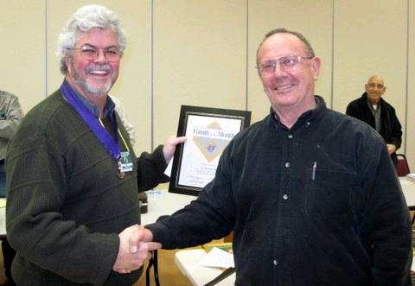
For December, this family continues to make a strong contribution to the Parish and Council. He is in charge of our bi-monthly Pancake Breakfasts, Co-Captain of the 11:30 Mass ushers and has worked diligently on such fundraisers as the Hoedown and October Fest. She is equally if not more active at Divine Savior where she sings in the choir and actively participates in WINGS. They represent the type of parishioners, through their Christian faith, caring attitude and devotion that symbolizes Divine Savior. Indeed, we are fortunate to have them.

Please join me in congratulating Joe and Joanna Rapier as our Family of the Month.

New Knights:
(As presented by Charlie McDermott)

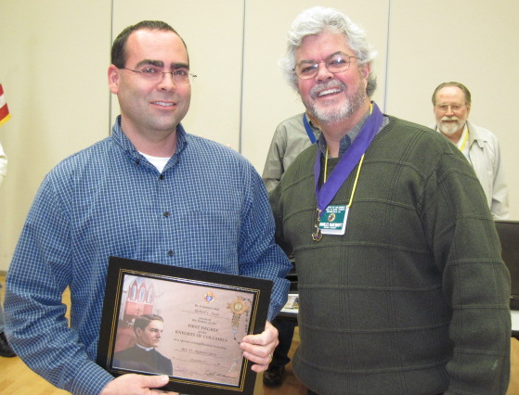

Please welcome Rich Dunn, his wife Melanie, and their 3 children: Marrisa (7), Garrett (7) and Natalie (5)!!!

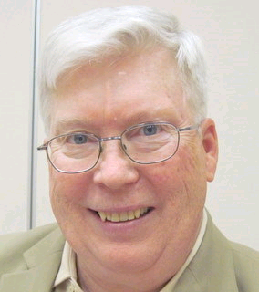
Recorder’s Motions
(As presented by Ray Coughlin)

At the January 5th, 2010, business meeting, the following motions were presented, seconded, and passed by the general membership present:

- Under Old Business: The motion presented at the December general membership meeting, seconded, and published, was passed: That the Council amend the By-laws Article 1 Section 3 as follows: "Each member shall pay annual dues, the same to be payable quarterly in advance at the first regular meetings in January, April, July, and October. The annual dues of members shall be $37.00, excepting insured members under the age 26 years of age whose dues shall be one-half of those sums, honorary life members who shall pay $12.00, and honorary life members who shall pay nothing. Except as above stated, the dues of associate and insurance members shall be the same. (Amended 01/05/2010)." Maker: Michael Wagner; seconded by: Ray Coughlin. Type of Funds: General.

- Under New Business, the following motions were presented, seconded, and passed by the general membership present:

- To pay all monthly bills presented at the meeting,

- Approve a change to the approved 2009/2010 budgets. Change the line item "Charity Expense - Wheelchair Foundation" to read "Charity Expense - American Wheelchair Mission". This will not change the amount budgeted. Maker: Michael Wagner; seconded by: Ray Coughlin. Type of Funds: Charity,

- That the Council advance PGK Joe Luchi $500.00 to purchase food and supplies for the spaghetti dinner on January 23,2010. This is a budgeted item. Maker: PGK Joe Luchi; seconded by: Ray Coughlin. Type of Funds: General,

- That the Council advance Don Marnach $300.00 to purchase drinks and supplies for the spaghetti dinner on January 23, 2010. This is a budgeted item. Maker: Don Marnach; seconded by: Ray Coughlin. Type of Funds: General,

- That the Council advance Joe Rapier 4250.00 to purchase food and supplies for the pancake breakfast on Jan 17th, 2010. This is a budgeted item. Maker: Joe Rapier; seconded by: Ray Coughlin. Type of Funds; General.

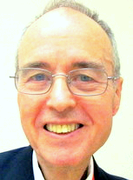
District Deputy News
(As presented by Eldon Hancock, District Deputy)

Topics from District Deputy have been included in other parts of the Newsletter.

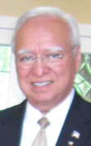
District Insurance News
(As presented by Tony Magdaleno)


KNIGHTS OF COLUMBUS INSURANCE
Making a difference for life

A letter of Thanksgiving and Gratitude for a better Year

My Dear Brothers, Wives, Families and Friends,

My deepest thanks and appreciation for all your thoughts, prayers, cards, letters, notes, support and phone calls.

A blockage in one artery was all it took to cause my heart attack. I guess that’s all that’s needed though to cause the heart to stop. Complications behind me, I’m recovering nicely, thanks be to God and feel I’m getting stronger by the day. This week I’m making appointments and plan to be up to speed very soon… I’ll be in cardio rehab a couple times a week as part of my strength-gaining program as well. I’ve missed being involved at all the functions and realized what a big part of my life you all are to me. I’m very much looking forward to reconnecting with everyone.

You truly never know my Brothers! Let’s make 2010 the best, by making sure we’re all prepare. I can personally attest to a greater peace of mind when I smile at my kids knowing it’s all done and in place.

God bless you all.

Fraternally, Your Brother and Field Agent,

Tony Magdaleno (916) 470-9205
FA 14661
CA Lic. #OG27147

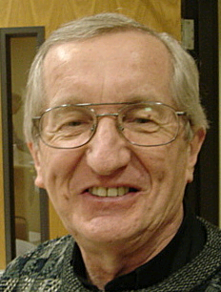
Reflections from the Chaplain
(Fr. Roman Mueller, SDS)

Dear Knights and Ladies:

The gray of winter seems rather prevalent these days; however, as followers of Jesus, we pray that regardless of the weather, we might be bright bearers of the light of Christ.
This is especially our mission in our world today that seems to be filled with a considerable amount of turmoil. A major part of our mission as followers of Jesus is to keep focused on the goodness and love of God as revealed in the person of Jesus.
We are called to be people who let that glorious light shine into all aspects of our lives. This is especially the case when it comes to what we call “hot button issues.” As member of the Body of Christ, one of our privileges is to help each other think matters through, even those in which we have invested significantly in any way.
Like any grouping of human beings, we are a divergent people; how is it that we can find ways to speak calmly about even the most controversial issues with the intention that we want to learn about some of the complex aspects of some of these serious topics?

Some say, “Why bother? There is nothing we can do about it anyhow.” There is a saying that knowledge is power. When we are closed off to discussion of touchy subjects, it seems that we are not inclined to learn about them. This is an understandable situation because if we found out more about certain things, we might be invited to change our opinions or convictions about them. And this kind of change is one of the most difficult ones to make. Realizing that there is more to the point at hand than we might think or know is quite a challenging situation. But if we are convinced that the love of God can and will help us through these challenges, wouldn’t it stand to reason that we would develop both greater knowledge as well as a deeper relationship with the love of God?

How can the Knights be a leading group in helping our faith community discuss hot topics while maintaining and strengthening the bonds of true Christian community?

Fr. Roman Mueller, S.D.S.



Let the Sunshine
(As presented by John Ridge)

We thank John for all his work in providing words of kindness and encouragement over the years as our Sunshine Committee Chairman. For future need, please remember to contact Tom Hogan with any sunshine activity or prayer cards that need to be sent.

You can contact Tom at 916-988-2184 or 1mosel@comcast.net.

Remember that we really don’t know how far a little kindness will go.

Committee Report - Membership
(As presented by Ray Coughlin)

New Knights
In the month of December, we had 2 transfers, Teciano Esternon and Leorico Oquendo. In January, we had Richard Dunn and Steven Hunt take their first-degree exemplification at St. Clare I Roseville. The next first is January 24th at St. John Vianney in Rancho Cordova.

Second and Third Degree Exemplification

The next second and third degree exemplification is March 6th in Carmichael. The membership team will be contacting all first degree Knights soon to schedule their exemplification.

Our membership tally is now at 124 members. If you know of someone who would like to join our council, please refer them to Ray Coughlin at (916) 989-4226 or Tony Magdaleno at (916) 470-9205.

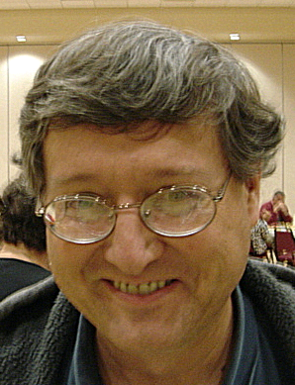

Committee Report - Youth
(As presented by Bill Manos)

Bill Manos reported that the CYM Potato Buffet/Dessert Bar event on Dec 13, at which our council baked and served potatoes, was successfully completed with the help of several Knights.

Bill also announced that the Free Throw Championship will be on January 10th, starting at noon, at St. John the Baptist.
A Scouts spaghetti feed is planned for Feb 22 and the Knights have been asked to assist with the cooking. Contact Bill to help at this worthwhile event.

Bill and his team are completing work on the Scholarship program.

Please contact Bill Manos at 965-3834 with any Youth Service Program questions.

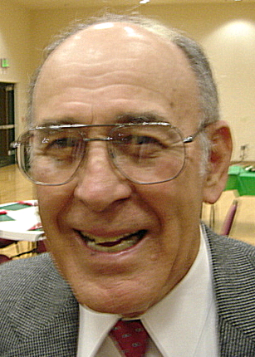

Committee Report - Family
(As presented by Guy Sanchez)

Guy Sanchez gave the final report on the Council Christmas Social held December 4.

The event came in under budget, over 80 attended, and Guy and Sandra received an ovation for their planning and execution.

A highlight was the presentation of the many Nativity scenes. Many thanks to Guy and Sandra and all those who helped.

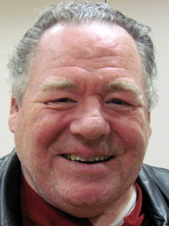
Please contact Guy Sanchez at 965-3834 with any Family Service Program questions.

Committee Report - Council
(As presented by Bill Windle for
Kelvin Joiner)

Our next Pancake Breakfast will be Jan 17. A Blood Drive will be held in conjunction with that event. To assist, contact Joe Rapier.

The final income reported from the recycle day is $594.10.
Volunteers are needed for all aspects of the January 23 Spaghetti Dinner. Joe Luchi is heading up this, our next major, fundraiser event. Tickets are on sale after all masses through the 17th. Contact Joe to assist.

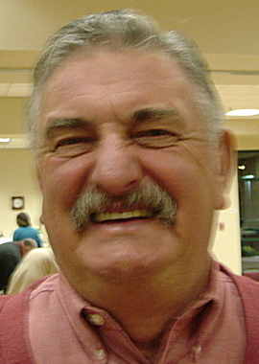

Committee Report – Church
(As presented by Dan Freeman)

Catholics Come Home commercials are now being broadcast on television.

Michael Hopper has been selected as our Seminarian. We hope to have pictures and bio info at our next meeting.

Assisting the parish environmental committee, our council prepared the church for Christmas: decorating and setting up extra chairs before, and removing the chairs after. Dan Freeman asked for assistance un-decorating on Jan 10th.

Please contact Dan Freeman at 987-0908 with any Church Service Program questions

.

Committee Report - Community
(As presented by Tony Aiello)

Community Service Program Director, Tony Aiello, and his team are working on several items.

Planning is underway for our Golf Tournament in May.

The committee is discussing ways of marketing to the community by bringing the community into our events.



Committee Report – Pro-Life
(As presented by Dave Brodie for Mike Schafer)

A couple major events are nearing.

- 40 Days to Life: We are asked to pray at several clinics in the area.

- Walk for Life will take place in San Francisco. Buses are available.

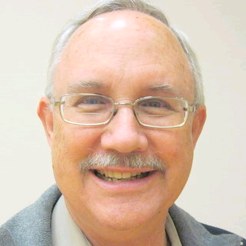

Future Council Planning Report
(As presented by Bruce Pyle)

Bruce and Bill Wagner are planning our council’s involvement in a fireworks sale this coming Fourth of July. The committee is looking for a location and is meeting with fireworks companies.
Other possible future events being discussed include a Hoedown in June, Octoberfest in September,
and an event to honor Veterans in November.
Inputs on these, and other ideas, are solicited.

Bruce also asked all brothers to consider accepting an office or chairmanship for the coming year (terms begin in July). Contact Bruce or any of the officers to reserve your position of council leadership.

Reminders to all: Please take pictures at events you attend so they can be shared at our social hour following regular meetings and be incorporated in our final reports.



Special Prayer Intentions

Please keep the following people in your prayers:

- George Mann- father of Steve Mann (deceased)
- Julia Rapier- mother of Joe Rapier (memory)
- Earl Varney (pneumonia/out of the hospital)
- Tony Magdaleno (heart complications)
- Sick: Paul Hoefling, Barbara Lawson, Paul Pyle, Ladene Carvalho, Ernie Deus, Eldon Hancock, Martin Jennings, Jack Joiner and Beverly Ridge
- Deceased: Bob Brodie and Toodie Jennings

January 2010 / February Birthday List


Name Birthday

John Hill 4-Jan
Michael Lawson 11-Jan
Vincent Papa 15-Jan
Allen Brown 24-Jan
Dan Freeman 24-Jan
Martin Jennings 31-Jan
Arthur Starkovich 10-Feb
Norbert Wollak 17-Feb
Deacon Charles Marchese Jr 22-Feb
John Carvalho 23-Feb
Alan Olson 25-Feb
John Tremblay 27-Feb

We would like to wish each of the above members a Happy Birthday!

Our Upcoming Events

Date Event Day(s) Location Charity Focus
5-Jan Business Meeting Tuesday Parish Hall
10-Jan Free Throw Competition Offsite
17-Jan Blood Drive Sunday Parish Hall
17-Jan Pancake Breakfast Sunday Parish Hall Boy Scouts/Alter Boys/ Youth Rally
23-Jan Spaghetti Dinner Saturday Parish Hall Divine Savior Bld Fund
28-Jan Officers Meeting Thursday

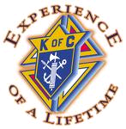
February
2-Feb Business Meeting Tuesday Parish Hall
20-Feb Membership Weekend Saturday & Vestibule
Sunday
25-Feb Officers Meeting Thursday

March
2-Mar Business Meeting Tuesday Parish Hall
21-Mar Pancake Breakfast Sunday Parish Hall Columbian Retirement Home
25-Mar Officers Meeting Thursday
28-Mar Corporate Communion Sunday Main Church

April
6-Apr Business Meeting Tuesday Parish Hall
16-Apr Council Social Friday Parish Hall
24-Apr Recycle Day Saturday Saturday Church St. Vincent DePaul
Parking Lot
29-Apr Officers Meeting Thursday

